Arduino Uno

Source: <https://www.udemy.com/course/arduino-sbs-17gs/>

# Ranges:

0v - 3v 🡺 LOW

3.5-5v🡺 HIGH

# Pull Down resistor:

Without the pull-down resistor while button is up the value of pin 5 is floating undefined.

So in order to solve this 🡺 add high resistance connected to 5v so when button is up 🡺 pin 5 =5v

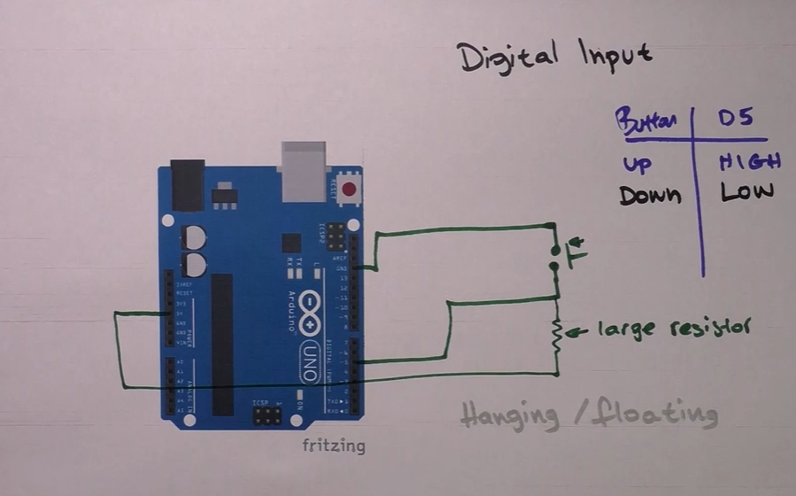

# PWM:

LEDs🡺ranges in value from 0 to 255

# Analog input:

Potentiometer

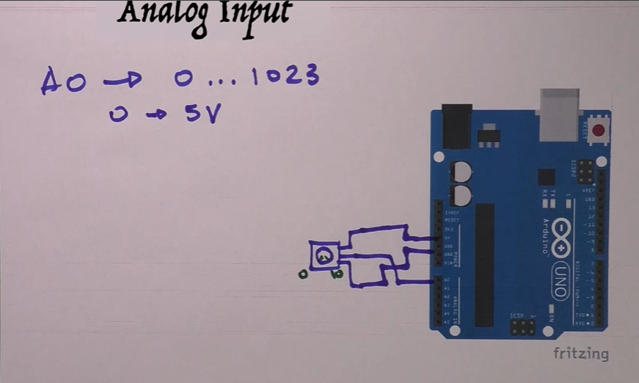

# Communication Protocols:

|  |  |
| --- | --- |
| Parallel Communication | Serial Communication |
|  |  |
| In 1 clock cycle (faster) | In 8 clock cycles (slower) |

Different Serial Communication Protocols:

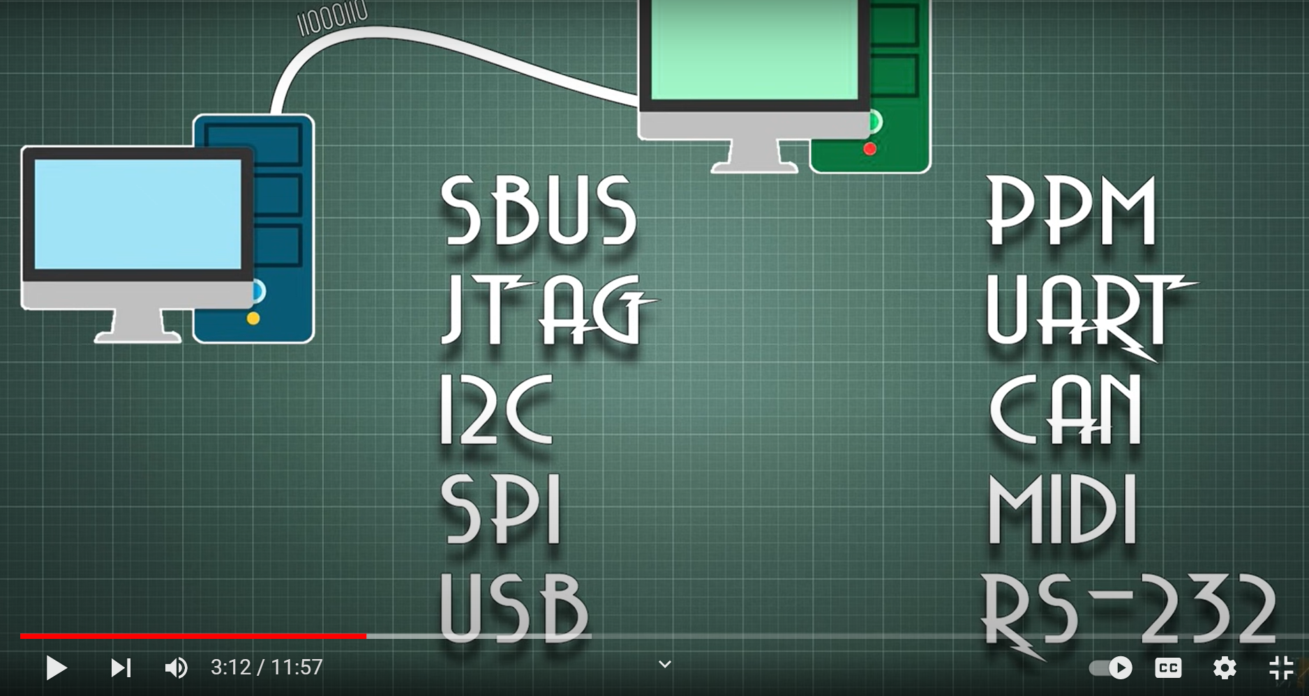

Arduino uno supports 🡺(UART – I2C – SPI)

Synchronous vs Asynchronous :

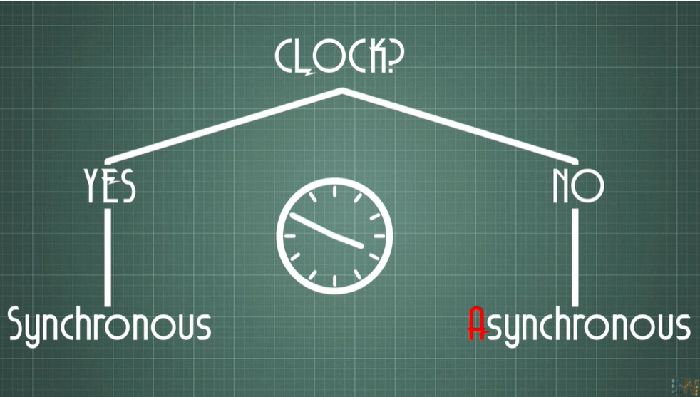

A synchronous protocol 🡺 uses the clock to send Data

An Asynchronous protocol 🡺 doesn’t use the clock to send data

But in case of Asynchronous there is no clock how to know when to send the next bit ??! 😐

Let’s start with the first protocol

## UART:

Universal Asynchronous Receiver-Transmitter.

1 line is used to send or receive unidirectional(RX - TX)

One master and one slave

But since it is Asynchronous we need common configuration between the receiver and the sender.

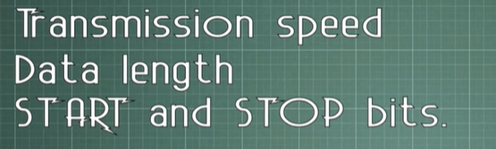

Data length & Start/Stop bits

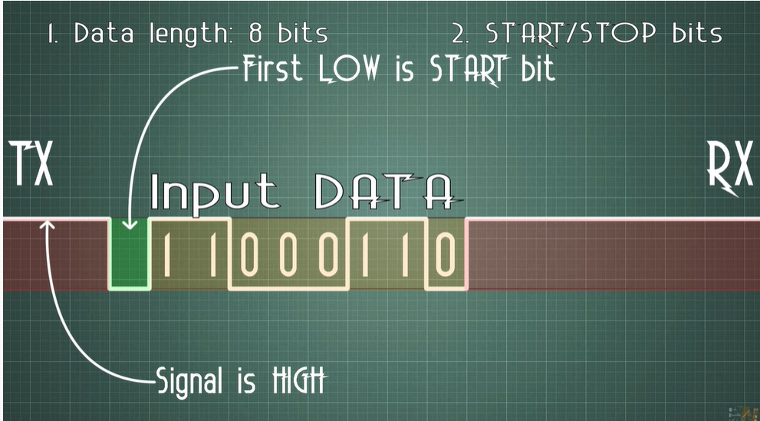

What about Transmission speed🡺 means for how long does the sender keeps sending this bit then turn to start sending the second successive bit.

Baud

a unit of transmission speed equal to the number of times a signal changes state per second. For signals with only two possible states one baud is equivalent to one bit per second.

. Baud rate refers to the number of signal or symbol changes that occur per second

Very common speed is 9600 bauds/sec

* The length of the bit will be 1/9600 sec

The two signals of each UART device are named:

* Transmitter (Tx)
* Receiver (Rx)

Pins 0 and 1

The main purpose of a transmitter and receiver line for each device is to transmit and receive serial data intended for serial communication.

Figure 2. UART with data bus.

In Arduino: pins 0&1

Note

Question 1:

Can your Arduino Uno communicate with the computer via USB and at the same time control an LED connected to digital pin 0? NO

Note: when uploading code the two pins 0 , 1 allow usb controller to communicate with the at mega 328p microcontroller to upload the code.

If you want to access more UART serial channels other than pin 0,1 🡺 you can use any of the digital pins and simulate the hardware functionality.

In some modules we have pins DTR(Data terminal ready) CTS(Clear to send so we don’t have flow problems.

DTR and CTS

You may be able to just ignore these signals. CTS (Clear To Send) and RT (Request To Send) provide a handshaking mechanism so that each device can tell the other when it's ready to receive data.

However, many Uarts don't implement this and either assume the other end can take data at any time or use another method such as XON/XOFF

Ex: I didn’t find it in he Bluetooth module

Hardware handshaking with RTS/CTS is not used very often on modern equipment but you will need to check the manual, a few devices still require it.

|  |  |
| --- | --- |
| Methods of Transmission | Asynchronous |
| Maximum Number of Masters | 1 |
| Maximum Number of Slaves | 1 |

## I2C(TWI):

Inter-Integrated circuit (Two Wired Interface)

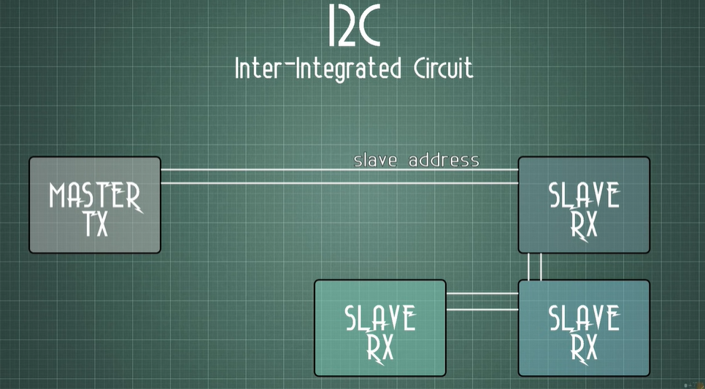

2 lines are used one for Data and the other for clock.

One Master to many slaves

**SDA (Serial Data)** – The line for the master and slave to send and receive data.

**SCL (Serial Clock)** – The line that carries the clock signal.

It is synchronous we still need common configuration between the receiver and the sender.

Simplex vs half Duplex vs full Duplex

Simplex mode is a uni-directional communication.

Half Duplex mode is a two-way directional communication but one at a time.

Full Duplex mode is a two-way directional communication simultaneously.

It is half Duplex only send or receive @ a time.

In Arduino: pins SCL & SDL.

Note:SCL (IS CONNECTED TO A5) and SDL IS CONNECTED TO A4) .

Question

In I2C, how many devices can be connected to an Arduino Uno at once?

You have a 7-bit address. That means you can address up to 127 slaves."

|  |  |
| --- | --- |
| Methods of Transmission | Synchronous |
| Maximum Number of Masters | 1 |
| Maximum Number of Slaves | N |

## SPI:

Serial Peripheral Interface Bus

4 lines:

SCLK: Slave clock

MOSI: Master out Slave in

MISO: Master in Slave out

SS: Slave Select

Here we don’t use here slave address instead we use slave select.

Full Duplex 🡺 the slave can send and receive from the master @ the same time

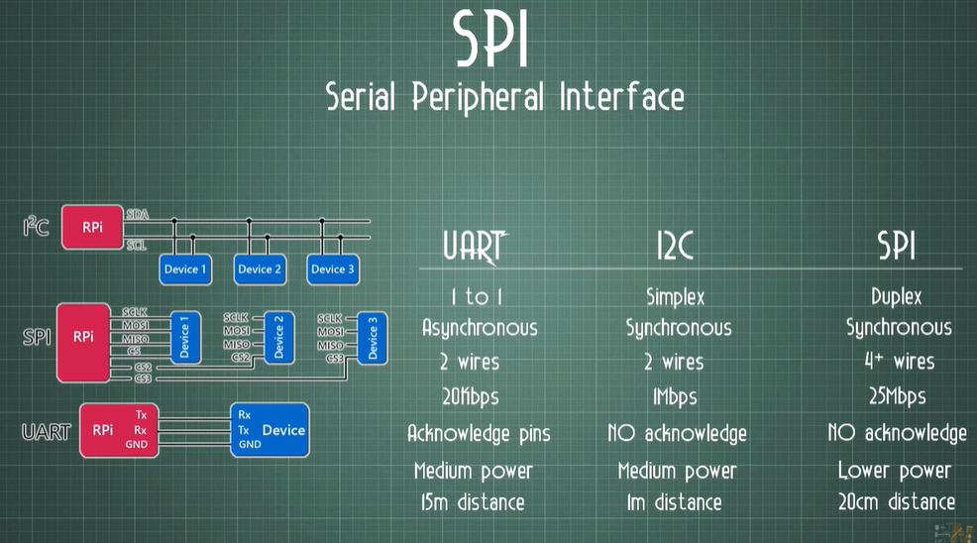

The Master sends data even if no slave is connected and the data isn’t received by any one (lost).

# Potentiometer:

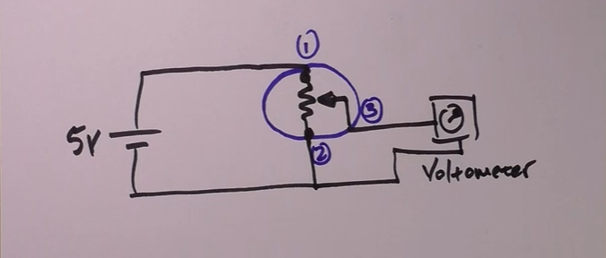

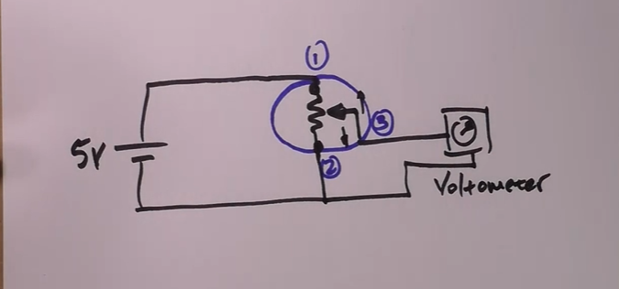QUESTION??